TOEFL Primary

Part 1
Exercise 1
Listen and choose the correct answer.
- How many brothers and sisters does Hayley have?
- Two
- Three
- Four
- Sara’s birthday is in
- March
- June
- November
- Sara’s hair is
- Short and dark
- Long and blond
- Short and blond
- Hayley and Sara do not both like the same
- Music
- Jokes
- Sports
- Where does Sara go with Hayley?
- To the shops
- To the cinema
- To parties

Exercise 2
Listen and choose the correct answer.
- Sara thinks the best age to leave home is
- Sixteen
- Eighteen
- Twenty

- Mike wants to learn drive because
- His parents never collect him from friends’ houses
- He needs to drive for the job
- Then he can come home later
- Grace says it’s better to get married when you are about
- Thirty
- Thirteen
- Eighteen
- Simon has got
- His own car
- A job in a shop
- A lot of money
Exercise 3
Listen and choose the correct answer.
- Which sport does Alfie dislike most?
- Basketball
- Rugby
- Football
- Alfie doesn’t like team sports because he doesn’t like
- His team
- Losing
- Competition
- Millie likes PE because
- She likes competition
- She likes team games
- She thinks it’s relaxing
- Millie thinks PE is important because
- Students don’t have enough time after school
- Students can get good grades
- Students need exercise during the day
- Alfie thinks that at school there should be
- Less sport
- Better instructors
- Different sports

Exercise 4
Listen and choose the correct answer.
- Where is the passenger travelling to?
- Frankfurt
- Rome
- Madrid
- Which platform is the train arriving on?
- 3
- 4
- 11
- Where does the woman want to go?
- Barcelona
- Basque country
- She is not sure
- How many nights has the man booked for?
- One
- Two
- Three
Exercise 5
Listen and choose the correct answer.
- The radio program is called
- Eat today
- Food today
- Drink today
- The Spanish omelet recipe is for … people
- 2
- 3
- 4
- Kate suggests we eat the omelet with some
- Vegetable
- Fruit
- Salad

- The presenter wants to know a healthy recipe for
- Desert
- Dessert
- Deserts
- Kate thinks it’s a good idea to eat … with the pancakes
- Drinks
- Fruit
- Salad

Exercise 6
Listen and choose the correct answer.
- Name of restaurant
- Star
- Light
- Starlight
- Price of two-course meal
- Seventeen pounds
- Sixteen pounds
- Eighteen pounds
- Type of food: traditional English and
- Oriental
- Traditional
- Untraditional
- Ana doesn’t like
- Hot food
- Spicy food
- Hot and spicy food
- Katy’s brother’s job is a
- Waiter
- Cleaner
- Dish washer

- Time for the meal
- Five
- Seven
- Six

Exercise 7
Listen and choose the correct answer.
- Price of cola
- 1.30
- 1.20
- 2.20
- Jane plays in
- The playground
- The field
- Play park
- Borrowing time for CDs
- A year
- A day
- A week
- Number of teachers in school
- 15
- 18
- 20
- Lesson in hall
- Classic
- Drama
- Comedy

PART 1
Look at the picture. Read the words. Which word goes with the picture?
Fill in the correct circle on your answer sheet.
Let’s do two example questions.

- 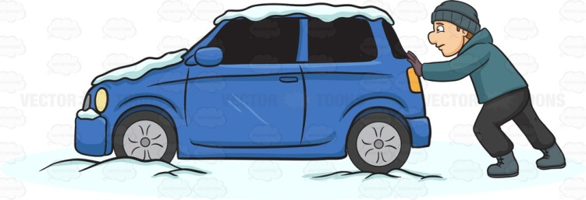
- Pushing
- Pulling
- Putting
The answer is ‘A’. Fill in ‘A’ on your answer sheet.

- 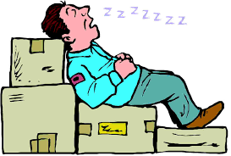
- He is working
- He is walking
- He is sleeping
The answer is ‘C’. Fill in ‘C’ on your answer sheet.
- 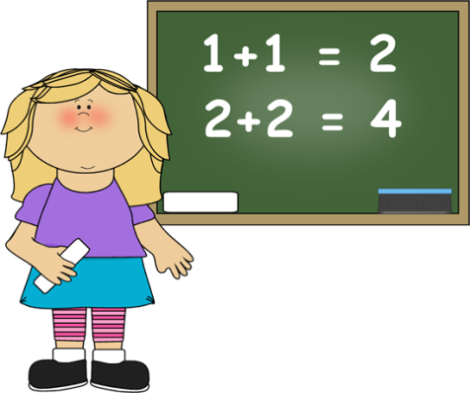

- Odd
- Add
- Minus

- 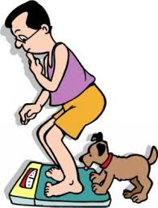

- Weigh
- Wait
- Height

- Debar
- Debark
- Debate

- 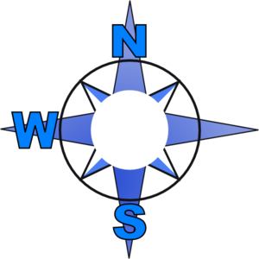
- South
- North
- East

- 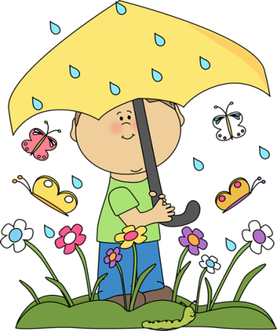

- December
- August
- April

- 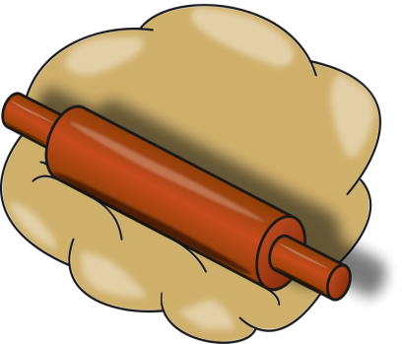

- Doubt
- Dough
- Daub

- 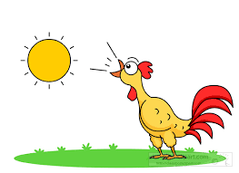

- Afternoon
- Morning
- Evening

- He is hewing
- He is cutting
- He is chopping

- 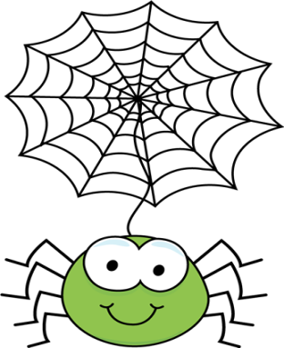

- It’s a spider’s web
- It’s a spider’s net
- It’s a spider’s home
- 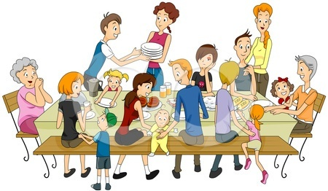
- Relatives
- Parents
- Grandparents
- 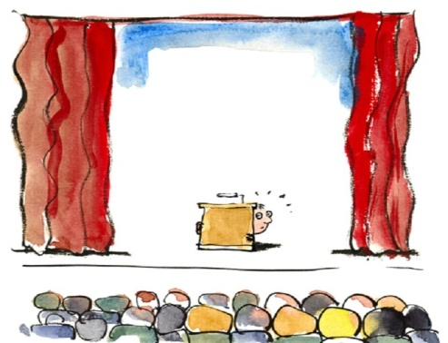
- Stage
- Stay
- Stab
- It’s a reward
- It’s a price
- It’s a number

- It’s a shelter
- It’s a prison
- It’s a house
Part 2
Read and find the answer.
Fill in the correct circle on your answer sheet.
Let’s do an example.
- Make an attempt or effort to do something
- Cry
- Try
- Fly
The correct answer is try. Fill in ‘B’ on your answer sheet.

- Something that is kept or meant to be kept unknown or unseen by others
- Secret
- Known
- Public

- Isolated and lonely
- Together
- Alone
- Collected

- Say something in order to obtain an answer or some information
- Answer
- Order
- Ask

- Very bad and unpleasant
- Beautiful
- Attractive
- Awful
- A place where someone lives or an organization is situated
- Address
- Direction
- House

- Something where you can read news, containing articles, advertisements and so on
- Book
- Newspaper
- Paper

- Doing something to achieve an aim
- Inaction
- Action
- Inactivity

- Put food into the mouth and chew and swallow it
- Eat
- Sleep
- Drink

- A large number of people gathered together
- Single
- Individual
- Crowd

Part 3
Fill in the correct circles on your answer sheet.
Read the story. Answer questions from 26 to 28.
Over a river there was a very narrow bridge. One day a goat was crossing this bridge. Just at the middle of the bridge he met another goat. There was no place for them to pass. "Go back," said one goat to the other, "There is no place for both of us".
"Why should I go back?” said the other goat. "Why should not you go back?"
"You must go back", said the first goat, "Because I am stronger than you."
"You are not stronger than I", said the second goat.
"We will see about that", said the first goat, and he put down his horns to fight.
"Stop!” said the second goat. “If we fight, we shall both fall into the river and be drowned. Instead I have a plan- I shall lie down, and you may walk over me."
Then the wise goat lay down on the bridge, and the other goat walked lightly over him. So they passed each other, and went on their ways.
- What was the problem?
- One goat had not horns for fight
- They didn’t like each other
- The bridge was too narrow

- If they fought
- One of them would win
- One of them would lose
- They would be go down

- What was the way out?
- They had to fight, one would be winner
- One of them would lay down on the bridge and the other pass him
- One of them would fall into the river and be drowned

Read a story. Answer questions from 29 to 31.
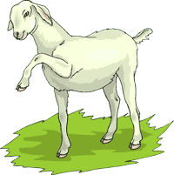
A wolf carried off a lamb. The lamb said, “I know you are going to eat me, but before you eat me I would like to hear you play the flute. I have heard that you can play the flute better than anyone else, even the shepherd himself."
The wolf was so pleased at this that he took out his flute and began to play.
When he had done, the lamb insisted him to play once more and the wolf played again.
The shepherd and the dogs heard the sound, and they came running up and fell on the wolf and the lamb was able to get back to the flock.

- What is ‘flute’?
- A game
- A musical instrument
- A song

- Who is shepherd?
- Herdsman
- Hunter
- Farmer

- What kind of trick had the lamb considered?
- The lamb ran to the flock
- The lamb called the shepherd
- The lamb asked the wolf to play the flute in order to hand the sound to the dogs and the shepherd

Read a story. Answer questions from 32 to 34.
Two frogs had lived in a village all their lives. They thought they would like to go and see the big city that was about twenty two miles away.
They talked about it for a long time, and at last they set off to see the city.
It was a hot day, and they soon began to feel tired. They had only gone a little way when one said to the other, "We must be nearly there. Can you see the city?"
"No," said the other frog; "but if I climb on your back I might be able to see it."
So he climbed up on the back of the other frog to see the city.
Now when the frog put up his head, his eyes could only see what was behind, and not what was in front. So he saw the village they had just left.
"Can you see the city?” asked the frog who was below.
"Yes," answered the frog that had climbed up. “I can see it. It looks just like our village."
Then the frogs thought that it was not worthwhile going any farther. They went back and told the frogs round the village that they had seen the city, and it was just like theirs.

- The city was
- About twenty miles away
- About twenty one miles away
- About twenty two miles away

- What does ‘set off’ mean?
- Intend
- Neglect
- Ignore

- Frogs are
- Clever
- desirous
- Lazy

Read a story. Answer questions from 35 to 37.
A man had a little dog, and he was very fond of it. He would pat its head, and take it on his knee, and talk to it. Then he would give it little bits of food from his own plate.
A donkey looked in at the window and saw the man and the dog.
"Why does he not make a pet of me?" said the donkey.
"It is not fair. I work hard, and the dog only wags its tail, and barks, and jumps on its master's knee. It is not fair."
Then the donkey said to himself, "If I do what the dog does, he may make a pet of me."
So the donkey ran into the room. It brayed as loudly as it could. It wagged its tail so hard that it knocked over a jar on the table. Then it tried to jump on to its master's knee.
The master thought the donkey was mad, and he shouted, "Help! Help!". Men came running in with sticks, and they beat the donkey till it ran out of the house, and they drove it back to the field.
"I only did what the dog does," said the donkey," and yet they make a pet of the dog, and they beat me with sticks. It is not fair."
- A man treated the dog
- Like donkey
- Like a man
- Very gently

- Donkey … because of the dog
- Was jealous
- Was happy
- Was nervous

- The man thought
- Donkey was foolish
- Donkey was mad
- Donkey was smart

Read a story. Answer questions.

A mouse was having a very bad time. She could find no food at all. She looked here and there, but there was no food, and she grew very thin.
At last the mouse found a basket, full of corn. There was a small hole in the basket, and she crept in. She could just get through the hole.
Then she began to eat the corn. Being very hungry, she ate a great deal, and went on eating and eating. She had grown very fat before she felt that she had had enough.
When the mouse tried to climb out of the basket, she could not. She was too fat to pass through the hole.
"How shall I climb out?" said the mouse. "Oh, how shall I climb out?"
Just then a rat came along, and he heard the mouse.
"Mouse," said the rat, "if you want to climb out of the basket, you must wait till you have grown as thin as you were when you went in."

- At first mouse was
- Replete
- Hungry
- Thirsty

- What is the moral of the story?
- It’s important to keep moderation
- We must not miss any possibility
- The mouse must wait till it has grown as thin as it were when it went in.

